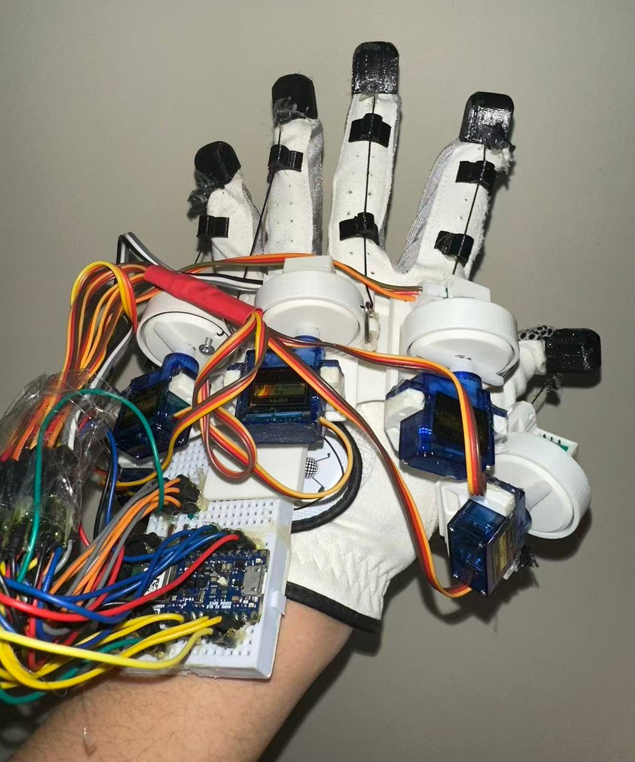
[ENBM002T]
SteadiGrip: Affordable AI Parkinson's Rehab
An Accessible, Low-cost, Multi-modal AI-
driven Wearable Platform for Parkinson’s Diagnosis and Personalized Closed-loop Rehabilitation

Macau Special Administrative Region, China

WU, HOI WING CHAO, SIN IEOK
HUANG, YEXIANG
Hou Kong Middle School
Note: All figures, graphs, and tables were created by the student researchers unless otherwise noted.

Fig. 1 The appearance of SteadiGrip

Problem
- Known Solutions

Parkinson’s: Incurable and only manageable, a chronic ordeal for both body and mind.^{[1]}
Parkinson's patients face significant motor deficits, yet existing rehabilitation devices are often

Drug(Medicine)
Side effects^{[3]}

Wearable Devices
- Only record
- Can’t intervene

Surgery
- High risk

expensive and lack personalized analysis. ^{[2]}

Common AI Solutions
Mostly cloud-based

Goal:
low-cost
accessible
multi-modal

Democratize Parkinson’s Treatment
Latency; Privacy Risk

Pneumatic gloves
Expensive; Hard to repair

I
Introduction
2

personalized
AI-driven
diagnosis
wearable
SteadiGrip
rehabilitation
offline
closed-loop
All of the above are constrained by time, place, budget, personalization, intelligence, safety, accessibility.

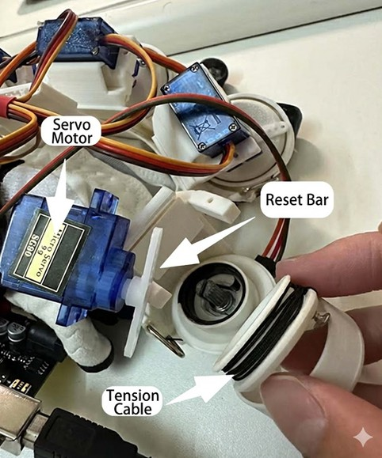

Fig. 3 Detailed look on the servo motors and tension cables
II
Methods: Design
3
(Translated by Nano Banna Pro in February 202C)

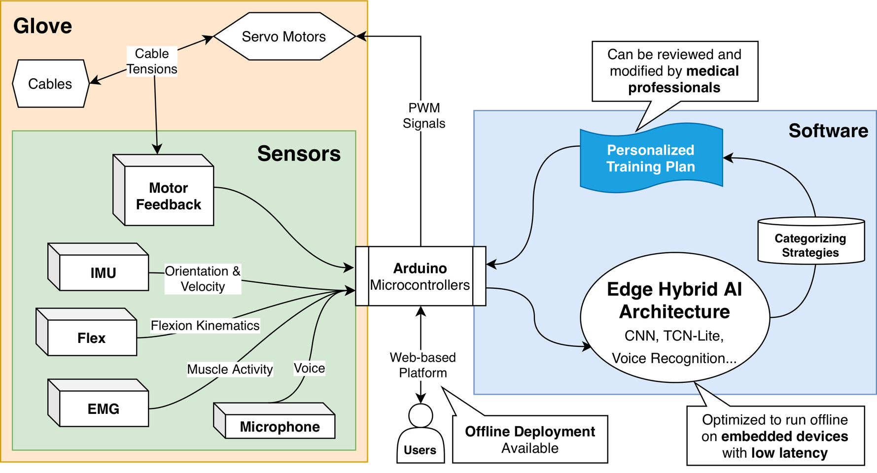
Fig. 2 Overall Architecture (Created using draw.io)

Hybrid AI Architecture
II
Methods: AI Algorithms and Model
4

Fig. 4 Graph of the Hybrid AI Architecture

Model Architecture
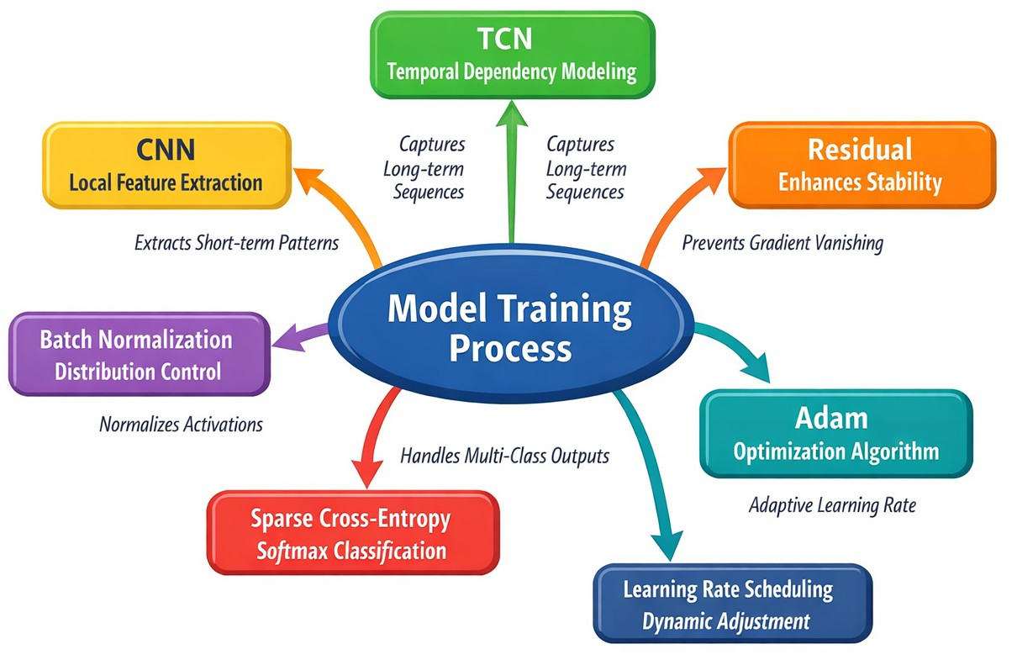
A lightweight hybrid CNN + TCN-Lite architecture
Separable CNN cut params for embedded devices.
5 MDS-UPDRS Parkinsons’ grades (0-4)
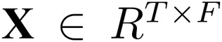
T=50,F=9
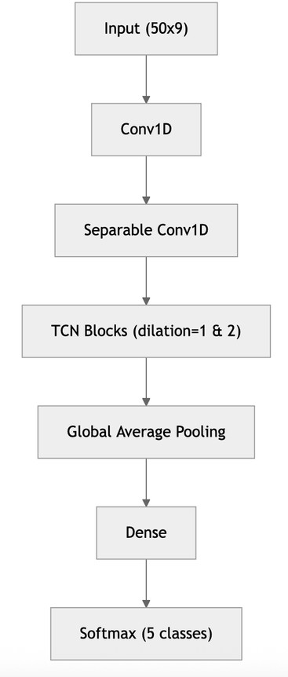
50: Timestamp
S: Feature Dimensions

(CNN) extracts local features
cut parameters for embedded devices

(TCN) handles long-range movement logic
Reduces the dimensionality & extract key motion features
Performs the final non-linear mapping &
outputs the probability distribution across
5 MDS-UPDRS Parkinsons’
grades (0-4)

II Methods: An easy-to-use web-based platform 5

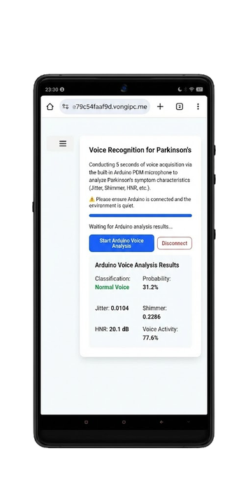

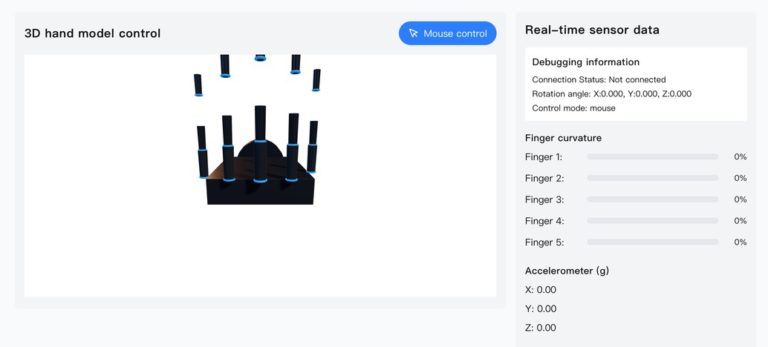

(a) (b)

(c)
Fig. 5 Screenshots of the Web-based Platform
((a)Translated by Google Nano Banana Pro in 202C Feb)

Platforms
Connect via Bluetooth, USB Computers
Desktops, Laptops
Portable Devices
Phones, Tablets
Specific Patient Manage Systems
Multi-systems
Windows, macOS, Linux iOS, Android...
Technology
Next.js
Based on React.js
Can be converted into PWA
Offline deployment
Three.js → Glove Data 3D Visualization

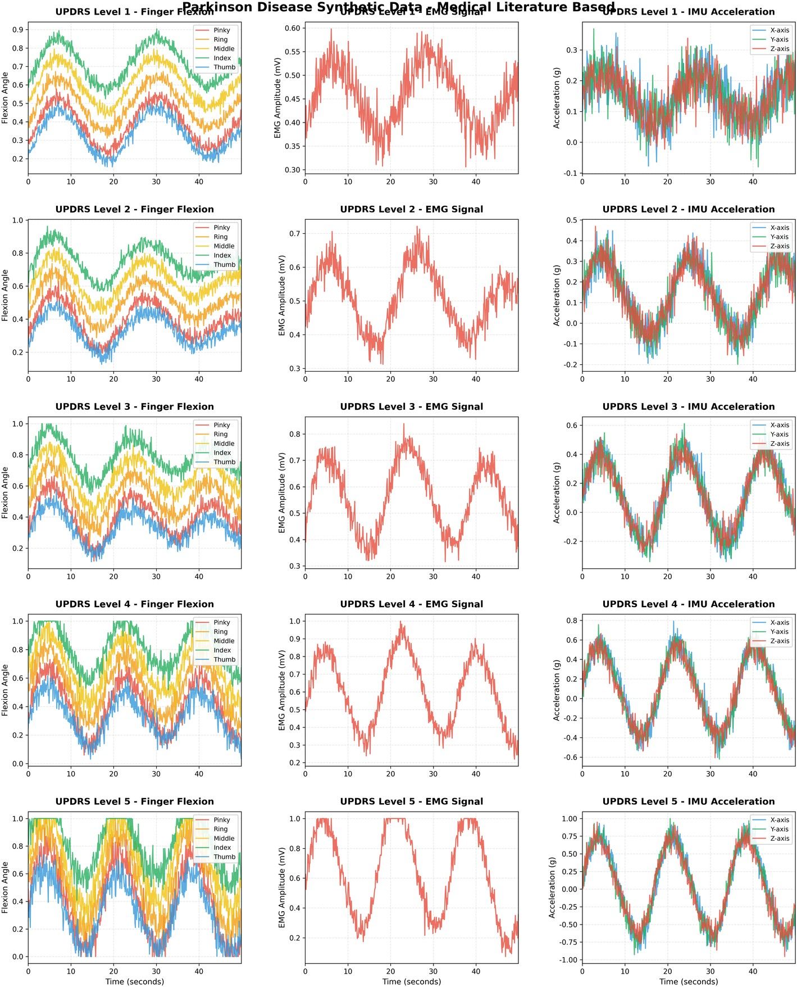
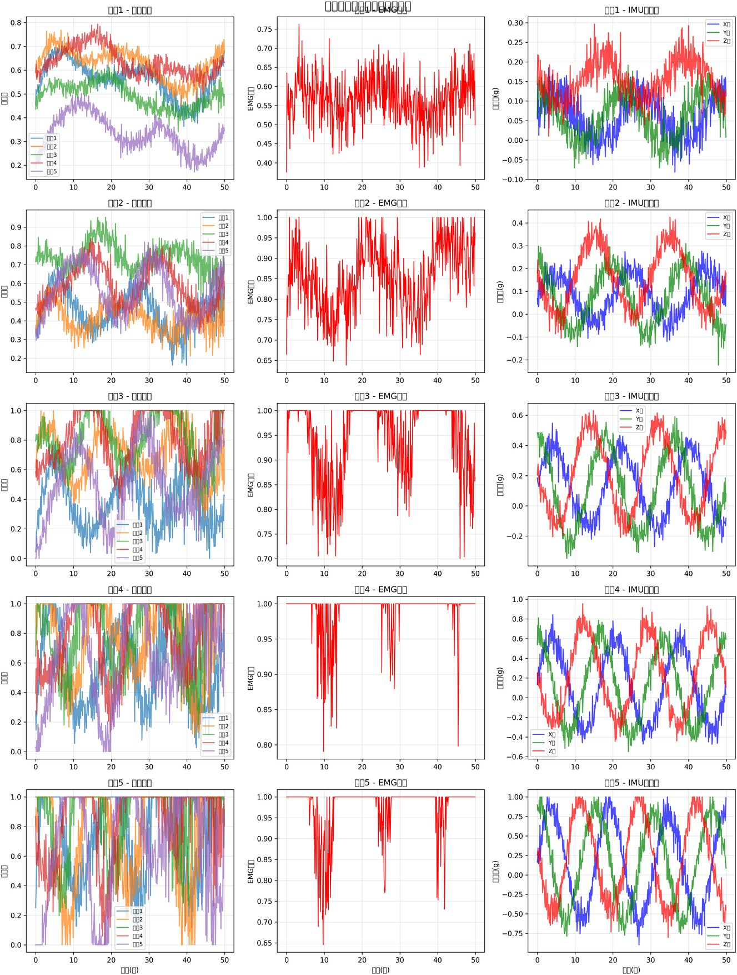
Data Generation Optimization for Edge (Offline) Deployment

Parameters Time Complexity
Sampling Rate
(real time processing) Memory Usage
7,573
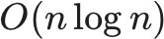

100Hz

≤7kb

Fig. C Data of PD patients vs. healthy controls across ge groups

Fig. 7 Data workflow based on medical standards
- Low latency
- Enable continuous monitoring
⇒
- Able to run on low-end embedded platforms
  - Arduino, Raspberry Pi
- Medical data protected

Simulation of Realistic Parkinsonian Symptoms via Physical Formulas^{[4][5][6]}
III
Results: Data C Model
6

Convolutional Layer Design

CNN[7]
Kernel size: K = 3 Activation: ReLU
TCN Dilated Convolution

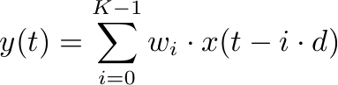

WHY: Depthwise
Separable Convolution?
param

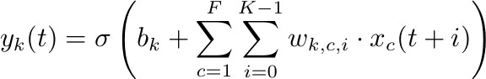
Step 1： Depthwise Convolution^{[8]}
- Enlarged receptive field
- Number of parameters

Other^{[G]}
SteadiGrip
32,477
7,573

III
Results: CNN C TCN
7
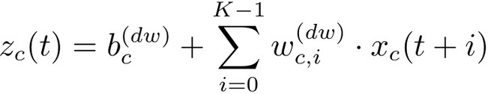
Step 2： Pointwise Convolution^{[8]}
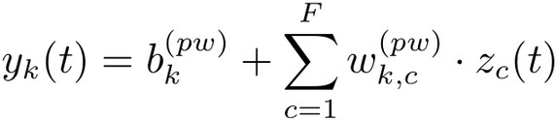
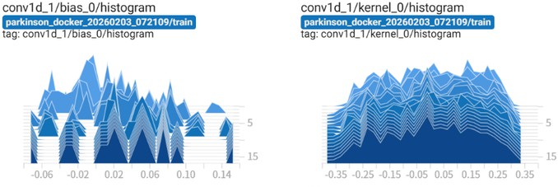
Fig. 8 Training result of the CNN
unchanged
- Without increasing computational complexity
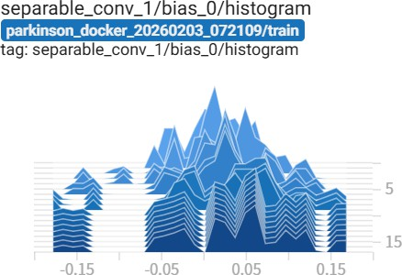
Fig. 3 Training results of the TCN.

Stable
⇒

Mostly distributed around 0

Efficiency Optimization!!
This directly lowers:
- SRAM usage
- MAC operations
- Energy consumption
- Inference latency Which is critical for:
- Arduino Nano 33 BLE Sense
- Cortex-M class MCUs
- Edge AI deployment

Residual Connection^{[10]}
III
Results: Performance
8

- Improves training stability
- Accelerates convergence
- Preserves low-level signal features
- Enables deeper TCN blocks
without degradation

Batch Normalization^{[11]}

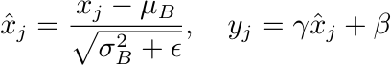
- Reduces internal covariate
shift
- Accelerates convergence
- Stabilizes multi-modal signal training
- Improves generalization

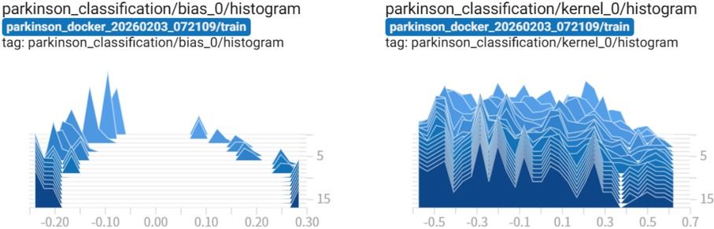
Classification Output Layer
Fig. 10 Training result of the Classfication

Training Performance
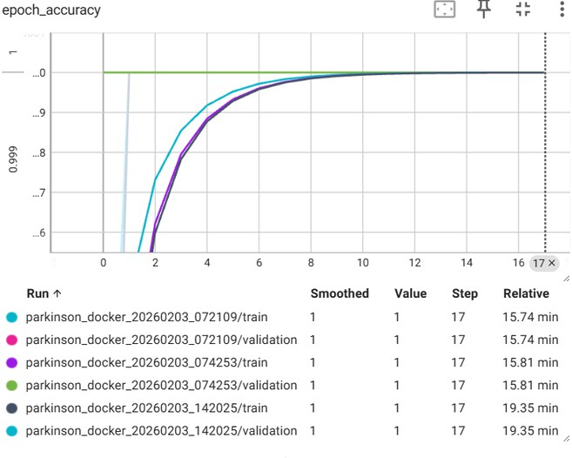
G8.2%
(initial goal)
80%
Fig. 11 Accuracy Evolution per Epoch

After 17 epochs:
- Training accuracy: 99.8%
- Validation accuracy: 98.2%
- Final loss: 0.012
- Training time: 15.74 minutes

“Democratize Parkinson’s Rehabilitation”
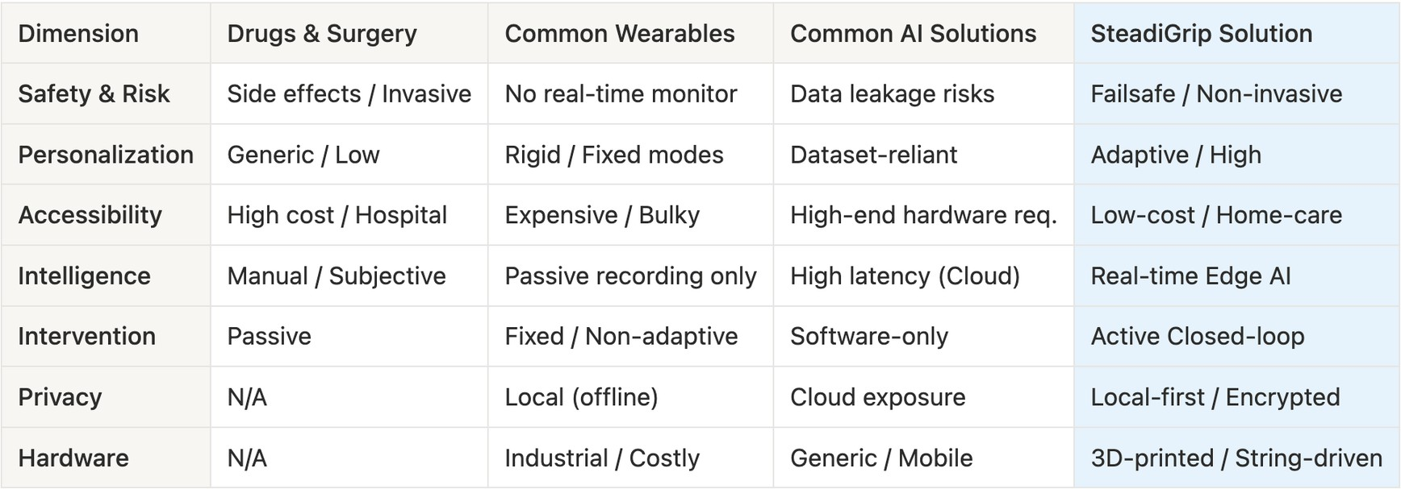
Extra Benefits Costs USD$ 22* ~ 50^

- Multi-Sensors Arrays

Embedding therapy into
*ESP32
$14.5
OR ^Arduino
$43.4

- Hybrid AI architecture
IV
Discussion: Why SteadiGrip
G
- Multi-Modals Analysis

everyday activities.
- Portable
→ Different ways to use
3D Printing Potentiometers Servos
Reset Buttons
$1.45 / total
$1.45 / 5 units
$3.62 / 5 units
$0.72 / 5 units

Data Diversity G Clinical Testing
IV
Discussion: Limitation C Work
10
Limit: As high school researchers with limited resources, clinical-level data collection and patient testing were not conducted due to
safety and privacy protocols.
Due to Macau’s small population base,
recruiting a statistically significant patient pool
locally is difficult; meanwhile, conducting
cross-border trials is logistically and financially challenging for high school researchers.
Work: Partner with medical institutions in Greater Bay Area (Macau, Hong Kong, Guangdong) to conduct authority-approved pilot studies in a controlled environment.

Mechanical Design G Materials
Limit: The current prototype primarily supports flexion and extension with limited lateral support.
Work: Integrate additional Degrees of Freedom (DOF) and use carbon-fiber materials for enhanced durability.

Scope of Syndromes
Limit: The prototype currently focuses on
upper-limb motor symptoms such as tremors.
Work: Adapt the modular AI-actuator framework to assist with lower-limb gait stability and recovery.

Closed-loop G Active Intervention
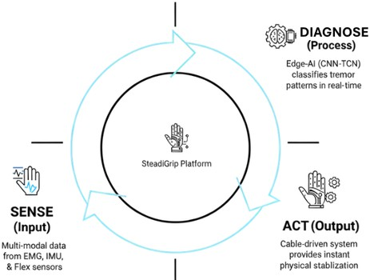
Personalized Closed-loop Care
Sense-Diagnose-Act
- multi-modal sensing
- AI analysis
- mechanical feedback.
Provides

Multi-modal G Privacy-First
Secure Multi-Modal Analysis

Multi-Modal
- Combines Motion and Voice diagnostics for holistic assessment
Privacy Preserving
🔒

- Dynamic Control
- Instant Stabilization Fig. 12 Cycle diagram

AI-Powered
Smart & Personalization
- Local-first data processing
ensures patient data security.

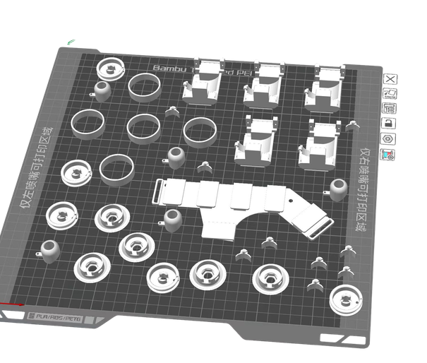

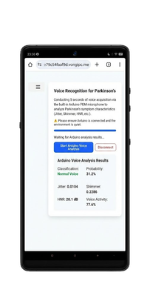
Social Impact
Democratizing Parkinson’s Rehabilitation
Fig. 15 Screenshots of the web-based platform
Fig. 14 3D printed parts

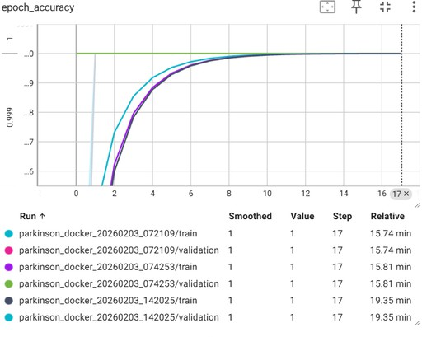
Hybrid AI Architecture
G8.2%
80%
(initial goal)
(CNN+TCN-Lite)
Performance on Embedded
7k params with 98.2% acc.
Low Latency
Real-time Edge Computing

Low cost Cross-platform; Easy to use

Fig. 13 Accuracy Evolution per Epoch “Anyone · Anytime · Anywhere”
V
Conclusion
11

- Poewe, W., Seppi, K., Tanner, C. M., Halliday, G. M., Brundin, P., Volkmann, J., ... C Lang, A. E. (2017). Parkinson disease. Nature reviews Disease primers, 3(1), 17013. https://doi.org/10.1038/nrdp.2017.13
VI
References
12
- Govindu, A., C Palwe, S. (2023). Early detection of Parkinson's disease using machine learning. Procedia Computer Science, 218, 249–261. https://doi.org/10.1016/j.procs.2023.01.007
- Mohammadi, M., Zolfagharian, A., Bodaghi, M., Xiang, Y., C Kouzani,
A. Z. (2022). 4D printing of soft orthoses for tremor suppression. Bio-Design and Manufacturing, 5(4), 786-807. https://doi.org/10.1007/s42242-022-00199-y
- Deuschl, G., Bain, P., C Brin, M. (1998). Consensus statement of the Movement Disorder Society on Tremor. Ad Hoc Scientific Committee. Movement disorders : official journal of the Movement Disorder Society, 13 Suppl 3, 2–23. https://doi.org/10.1002/mds.870131303
- Berardelli, A., Rothwell, J. C., Thompson, P. D., C Hallett, M. (2001). Pathophysiology of bradykinesia in Parkinson's disease. Brain : a journal of neurology, 124(Pt 11), 2131–2146. https://doi.org/10.1093/brain/124.11.2131
- Xia, R., C Rymer, W. Z. (2004). The role of shortening reaction in mediating rigidity in Parkinson's disease. Experimental brain research, 156(4), 524–528. https://doi.org/10.1007/s00221-004-1919-9
- LeCun, Y., Bottou, L., Bengio, Y., C Haffner, P. (1998). Gradient-based learning applied to document recognition. Proceedings of the IEEE, 86(11), 2278–2324. https://doi.org/10.1109/5.726791
- Chollet, F. (2017). Xception: Deep learning with depthwise separable convolutions. In 2017 IEEE Conference on Computer Vision and Pattern Recognition (CVPR) (pp. 1800–1807). IEEE. https://doi.org/10.1109/CVPR.2017.195
- Lee, S., Hussein, R., Ward, R., Jane Wang, Z., C McKeown, M. J. (2021). A convolutional-recurrent neural network approach to resting-state EEG classification in Parkinson's disease. Journal of neuroscience methods, 361, 109282. https://doi.org/10.1016/j.jneumeth.2021.109282
- He, K., Zhang, X., Ren, S., C Sun, J. (2016). Deep residual learning for image recognition. In 2016 IEEE Conference on Computer Vision and Pattern Recognition (CVPR) (pp. 770–778). IEEE. https://doi.org/10.1109/CVPR.2016.90
- Ioffe, S., C Szegedy, C. (2015). Batch normalization: Accelerating deep network training by reducing internal covariate shift. In International Conference on Machine Learning (pp. 448–456). PMLR. https://doi.org/10.48550/arXiv.1502.03167
Thank you for your time and consideration

